**Accessory Movements**

Accessory movements are the movements of the joint which cannot be performed voluntarily by the patient and that are the movements of the joint that allow physiological movement to occur.

Assessment

The individual accessory movements can be performed in order to improve physiological movement. The accessory movement should replicate the natural slide, glide or spin of the joint surfaces during normal movement. This involves taking the joint though its full available range (as pain allows) and looking for:

* Quality
* Range
* Pain reproduction
* End feel
* Muscle spasm
* Increased movement (hypermobility)
* Decreased movement or resistance to movement

Convex / concave rule

All joint movement obeys the convex concave rule which describes which direction one surface of the joint will move when the other is fixed.

The rule is as follows:

The concave surface will slide in the **same direction** as the bone is moving in when the convex surface is stable.

The convex surface will slide in the **opposite direction** of the bone is moving in when the concave surface is stable.

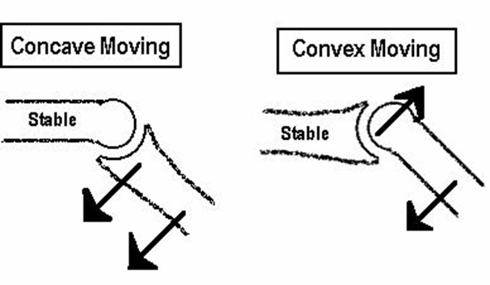

Directions

The directions of accessory movement are as follows:

* A/P – anterior / posterior movement
* P/A – posterior /anterior movement
* Lateral Glide
* Rotation
* Caudal glide – towards the feet
* Cephalad glide – towards the head
* Distraction / traction – gapping joint surfaces

These are documented using the following symbols:

↓ PA

↑ AP

→← Medial glide

←→ Lateral glide

←→ (caud) Caudad

←→ (ceph) Cephalad

←→ Distraction

→← Transverse (spinal)

ↄ  **C** Rotation

↓ ↓ Unilateral

Contraindications to joint mobilisations

* Inflammatory arthritis (active)
* Infection
* Ca
* Hyper mobility / instability
* Osteoporosis
* Trauma ( <48 hours )
* Fracture
* Spondylolysthesis

Precautions to joint mobilisations

* Trauma (post 48 hours)
* Vertebral Basilar Insufficiency (VBI) signs
* Rheumatoid Arthritis
* Post whiplash
* Acute muscle spasm / guarding
* Neurology / Upper Motor Neurone signs
* Pregnancy (third trimester)

Weblink

<http://www.physio-pedia.com/Maitland's_Mobilisations>